Nepal College of Information Technology
Assessment
Spring 2010
Program : BE ELX Time : 3 hrs
Semester : Spring (VI) FM : 100
Subject : Filter Design PM : 50

- Candidates are requested to give their answer as far as practicable in their own words.
- The figure in the margin indicates the full marks
- Attempt ALL question
1. a) Define filter. Illustrate different types of the filters according to their frequency responses in terms of both gain and attenuation. 7
b) For the given filter circuit 8
i) Find the transfer function.
ii) Plot pole-zero location.
iii) Plot magnitude response.
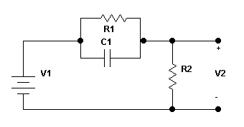
2. a) Determine the order of chebyshev response that realizes the following specifications: 10
i) Pass band extends from w=0 to w=250rad/s
ii) Attenuation within the pass band should not exceed 0.1dB
iii) Response must give at least 60dB attenuation at frequency w==2000rad/s or higher.
Also show the pole zero location, determine transfer function and Quality factor (Q).
b) Find the order and transfer function of Cauer filter that has α_{max}= 0.5 dB, α_{min}= 65 dB, ω_{p}=1000 rad/sec, ω_{s}=2000 rad/sec. 5
3. a) Compare between Butterworth Response, Chebyshev Response, Inverse-Chebyshev Response and Elliptical Response with suitable example. 8
b) What do you mean by Frequency Transformation? What is its Importance? Use frequency transformation to find the HP Filter network assuming suitable low pass prototype. 7
4. a) Why sensitivity analysis is necessary in filter design? Drive the transfer function of Sallen-Key biquad circuit, and perform its sensitivity analysis. 8
b) Design an active filter to realize the bilinear transfer function with zero at f_{z} = 830 Hz, a pole at f_{z} = 13 KHz and high frequency gain 23dB. Apply active realization. 7
5. a) Realize a third-order Butterworth low pass filter from LC ladder with unequal terminations R₁=1Ω and R₂=4Ω. 8
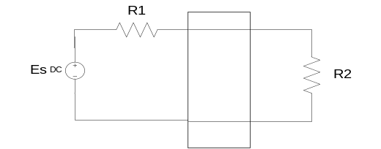
b) Design a Tow-Thomas biquad to realize transfer function 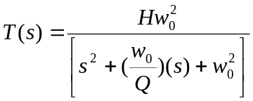 at normalized frequency and write down the tuning algorithm. 7
6. a) What is significance of FDNR? Simulate the 4th order Butterworth filter with the use of FDNRs such that its cut-off frequency is at 1000 Hz and also use 0.01μF capacitor only. 8
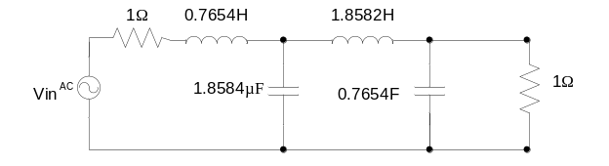
b) Design a switched capacitor MOS filter circuit which satisfies the given characteristics: 7
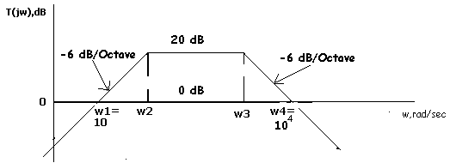
7. Write short notes on (Any Two):
a) Generalize Impedance converter.
b) RC – CR Transformation.
c) Insertion gain and Insertion loss.

TABLE 1: Butterworth Polynomials
Order | T (s)
N = 1 | S + 1
N = 2 | (s² + √2s + 1)
N = 3 | (s + 1)(s² + s + 1)
N = 4 | (s² + 1.8476s + 1) (s² + 0.7654s + 1)
N = 5 | (s+1) (s²+1.618s+1) (s²+0.618s+1)

ABLE 2: Pole Zero Locations for Butterworth Response
n = 2 | n = 3 | n = 4 | n = 5 | n = 6
-0.7071068  ± j 0.7071068 | -0.50  ± j 0.86603 | -0.3826834  ± j 0.9238795 | -0.809017  ± j 0.5877852 | -0.258819  ± j 0.9659258
 | - 1.0 | -0.9238795  ± j 0.3826834 | -0.309017  ± j 0.9510565 | -0.7071068  ± j 0.7071068
 |  |  | - 1.0 | -0.9659258  ± j 0.2588190

